 

**The Ice Centre is a LiveBarn venue!**

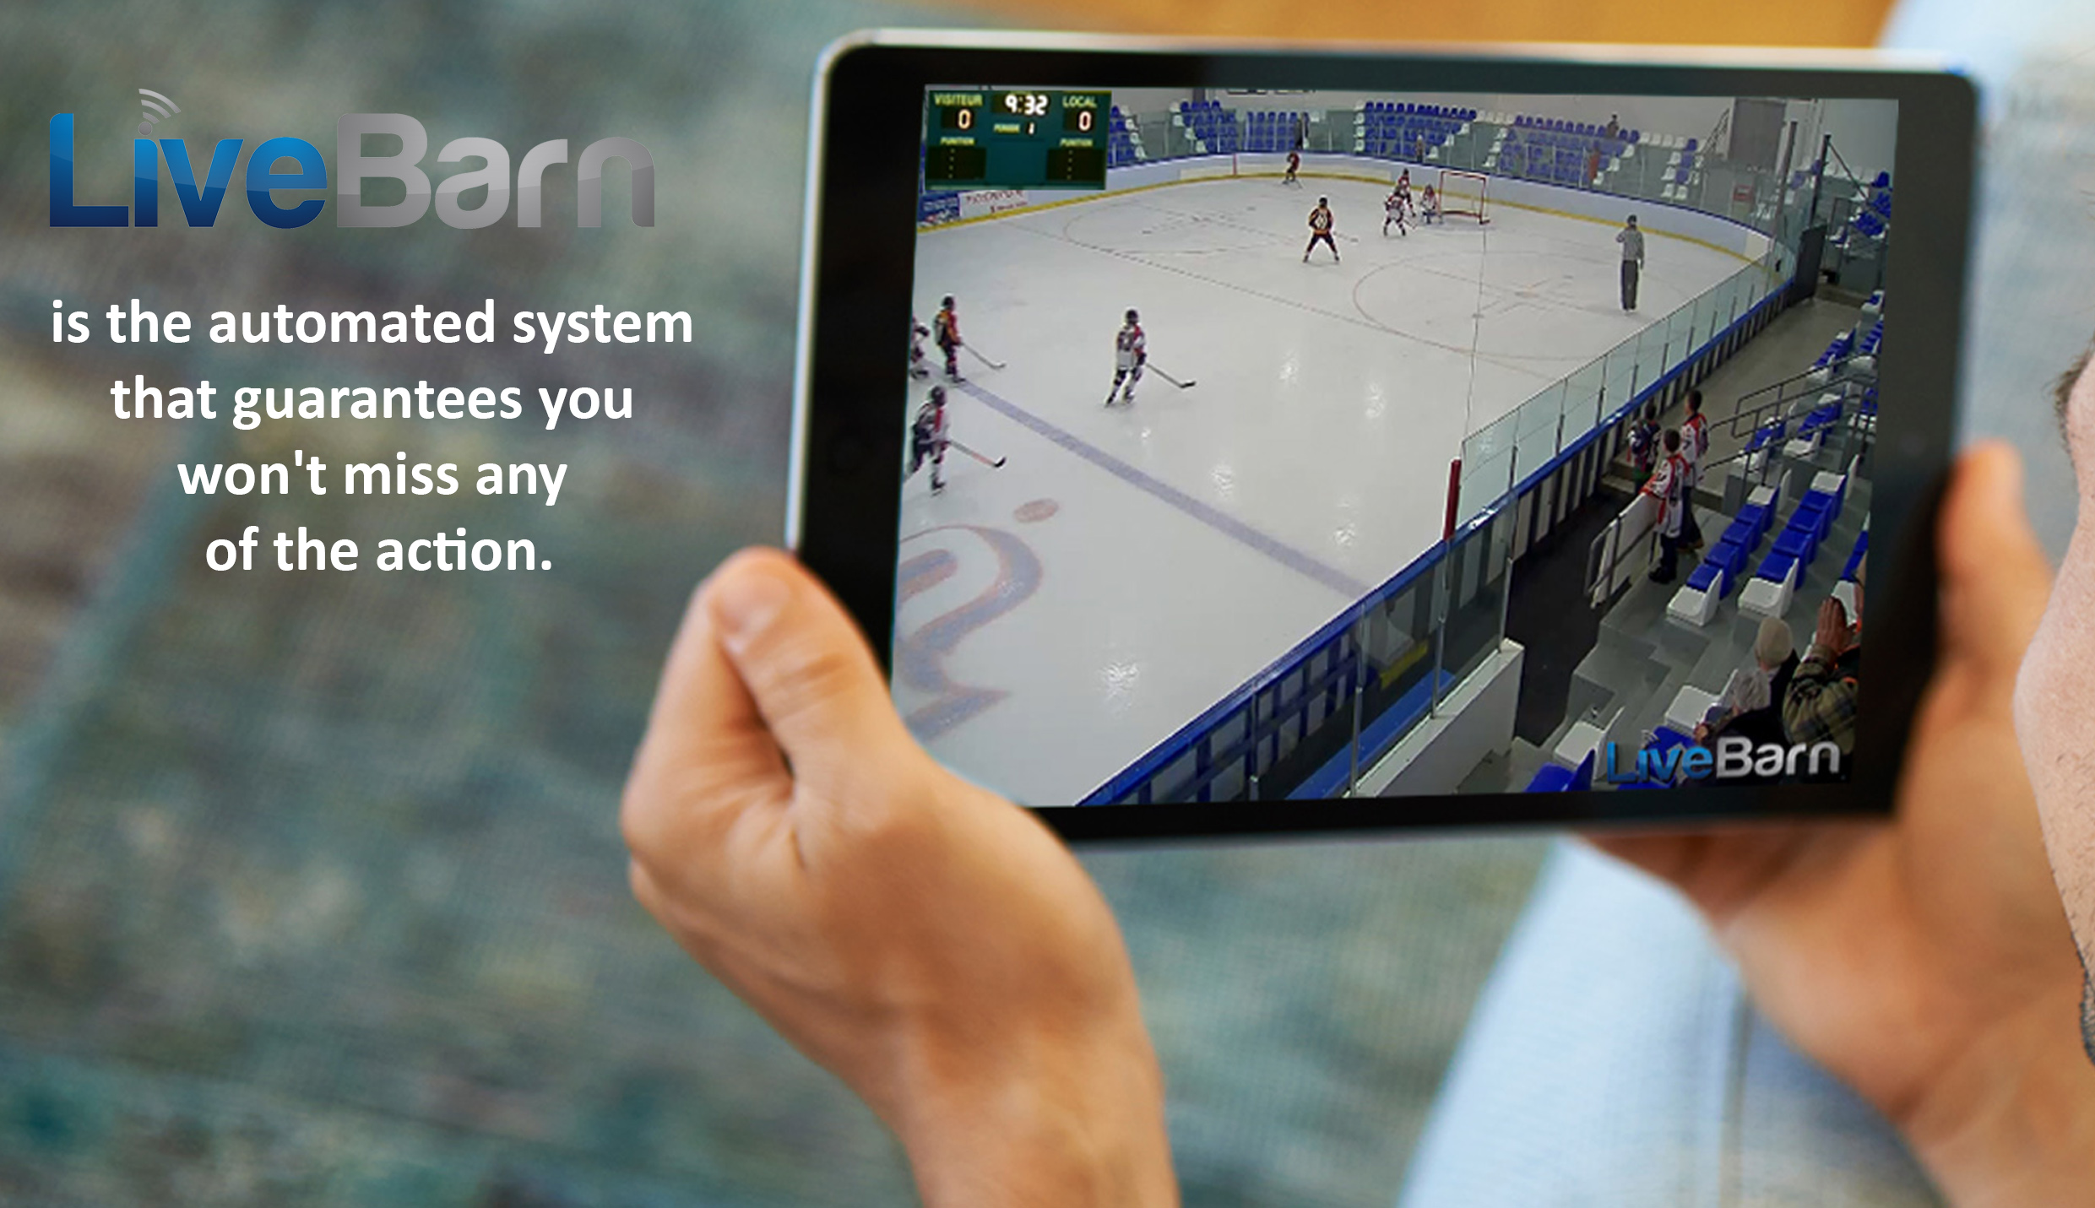

333f-121a

PROMOTION CODE:

Use the promo code above to start your

**Free 1 Day Trial** and **get 10% off your membership** at:

WWW.LIVEBARN.COM

Watch unlimited from any LiveBarn venue from $14.95/month

Share highlights via social

media and email

Watch games and practices

in HD, Live and On Demand

- anytime, anywhere,

on any device